Program: Panel Discussion - The Future of Talent Development

Panelists: Jessica Nojek, Russ Romans and Jillian Gonzales

Date: Thursday, April 18, 2019 5:30 PM - 7:30 PM

Location: Bohannan Huston 7500 Jefferson St. NE (NE corner of Jefferson and Masthead)

Program Description – With panelists from business, education and the non-profit world we will have a wide-ranging discussion on the future of talent development and what we can expect in the coming years in NM.

Panelist Bios -

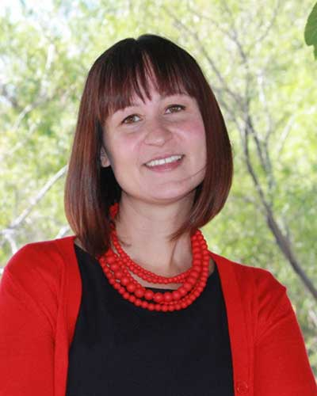
Jessica Nojek is the Executive Director of Mission: Graduate. She was previously at the New Mexico Department of Workforce Solutions (NMDWS) as the Statewide Youth Engagement Coordinator, working to empower statewide partners with best and promising practices in youth engagement, strategies for strengthening coordination with youth agencies and organizations and promoting statewide awareness of the unique workforce needs of New Mexico’s young people. This work included managing the creation and content for the state’s first online hub for internships. She is now excited to utilize all of her experience to support the goals of Mission: Graduate as Executive Director, working to improve the education outcomes in central New Mexico.

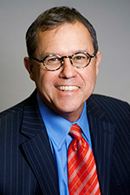
Dr. Russ Romans is a Lecturer in the Educational Leadership Program at the University of New Mexico. Dr. Romans has over twenty years experience in leadership training, organizational development and educational administration. As an administrator with the New Mexico Public Education Department he worked with the Priority Schools Bureau on a variety of school improvement initiatives. He also developed and directed a community leadership development program at the Gallup Campus of UNM. He is a Past President of the New Mexico Chapter of the American Marketing Association and the author of the first edition of Working Together: Parent, Family and Community Involvement in Education Toolkit produced by the Center for the Education and Study of Diverse Populations. He provided support for data analysis and training as the Accountability

( continued on next page )
Manager with the Albuquerque Public Schools. Romans holds a BA in Art from New Mexico
Highlands University, an MBA (Marketing) from the University of Illinois, a Doctorate in Educational
Leadership (Transformational Leadership & Organizational Learning) from the University of New Mexico and was a Fellow in Center for Educational Policy Research Strategic Data Project at Harvard University.

Jillian Gonzales is a seasoned organization development professional with a focus on change and transformation. She is highly skilled in coaching, facilitation, and training. Ms. Gonzales’s change and transformation skills are rooted in and influenced by Motivational Interviewing (member of MINT), Mediation practice and Gestalt Organization and Systems Development practices. She is a founding member of an international working group called MILO (Motivational Interviewing in Leadership and Organizations). Jillian is a returning native New Mexican with now over 15 years of diverse industry state-wide experience. She has been in various roles that provided opportunities to engage in talent development at the individual, group and enterprise-level. Currently, she is the Manager of Workforce Education and Development at TriCore Reference Laboratories.

Registration:
ATDNM Students Members – $15.00 (USD)
ATDNM Members – $20.00 (USD)
Professional Guests – $30.00 (USD)
Student Guests – $20.00 (USD)

Register at www.atdnm.org

